WEEK 5 : COGNIZANT DN 4.0 FSE HANDS-ON EXERCISES

(MANDATORY PLUS ADDITIONAL)

* **Microservices with API Gateway**

**Exercise 1: Creating Microservices for account and loan**

**Account.java**

package com.cognizant.account;

public class Account {

private int accountNumber;

private String accountType;

private double balance;

public Account(int accountNumber, String accountType, double balance) {

this.accountNumber = accountNumber;

this.accountType = accountType;

this.balance = balance;

}

public int getAccountNumber() {

return accountNumber;

}

public String getAccountType() {

return accountType;

}

public double getBalance() {

return balance;

}

}

**AccountController.java**package com.cognizant.account;

import org.springframework.web.bind.annotation.*;

*@RestController*

*@RequestMapping*("/accounts")

public class AccountController {

*@GetMapping*("/{number}")

public Account getAccountByNumber(*@PathVariable* int number) {

return new Account(number, "savings", 234343);

}

}

**AccountApplication.java**

package com.cognizant.account;

import org.springframework.boot.SpringApplication;

import org.springframework.boot.autoconfigure.SpringBootApplication;

@SpringBootApplication

public class AccountApplication {

public static void main(String[] args) {

SpringApplication.run(AccountApplication.class, args);

}

}

**application.properties**

spring.application.name=account

server.port=8080

**Output:**

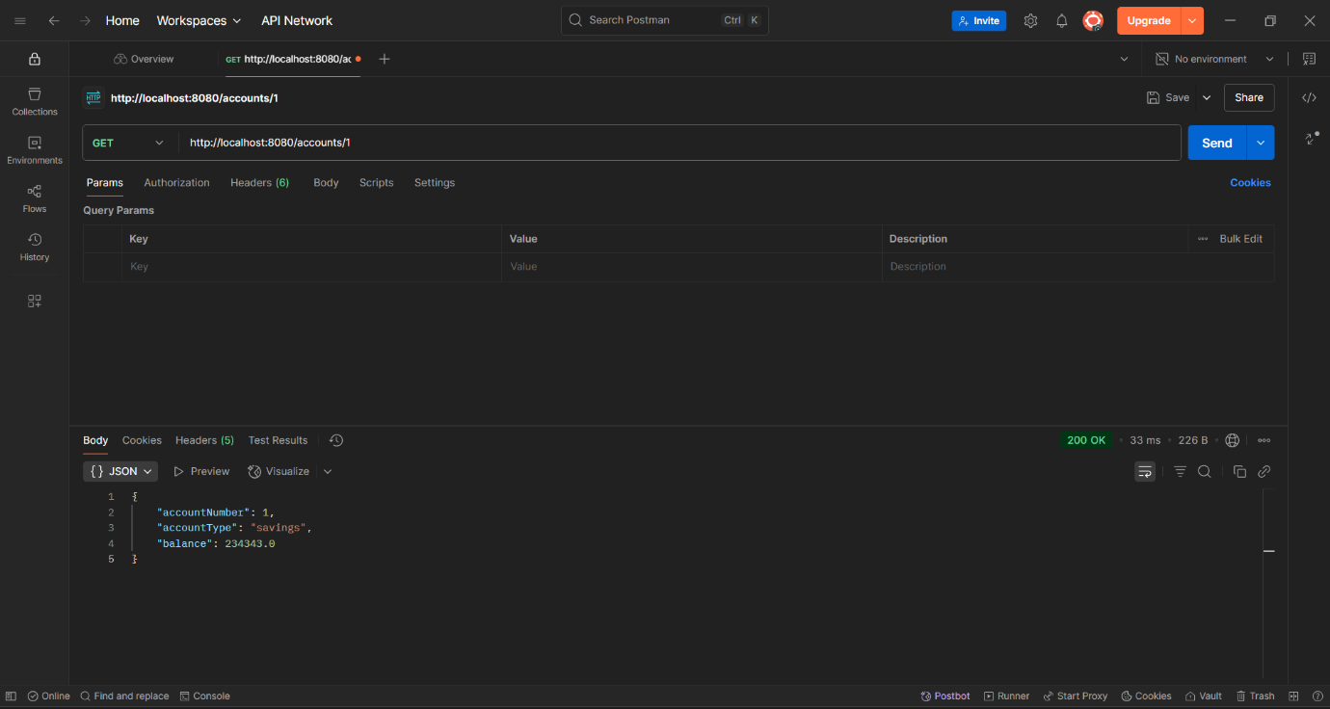

**Loan.java**

package com.cognizant.loan;

public class Loan {

private int loanNumber;

private String loanType;

private double loanAmount;

public Loan(int loanNumber, String loanType, double loanAmount) {

this.loanNumber = loanNumber;

this.loanType = loanType;

this.loanAmount = loanAmount;

}

public int getLoanNumber() {

return loanNumber;

}

public String getLoanType() {

return loanType;

}

public double getLoanAmount() {

return loanAmount;

}

}

**LoanController.java**

package com.cognizant.loan;

import org.springframework.web.bind.annotation.*;

import java.util.HashMap;

import java.util.Map;

*@RestController*

*@RequestMapping*("/loans")

public class LoanController {

*@GetMapping*("/{number}")

public Map<String, Object> getLoanByNumber(*@PathVariable* String number) {

Map<String, Object> response = new HashMap<>();

response.put("number", number);

response.put("type", "home");

response.put("amount", 500000);

return response;

}

}

**LoanApplication.java**

package com.cognizant.loan;

import org.springframework.boot.SpringApplication;

import org.springframework.boot.autoconfigure.SpringBootApplication;

@SpringBootApplication

public class LoanApplication {

public static void main(String[] args) {

SpringApplication.run(LoanApplication.class, args);

}

}

**application.properties**

spring.application.name=loan

**server.port=8081**

**Output:**

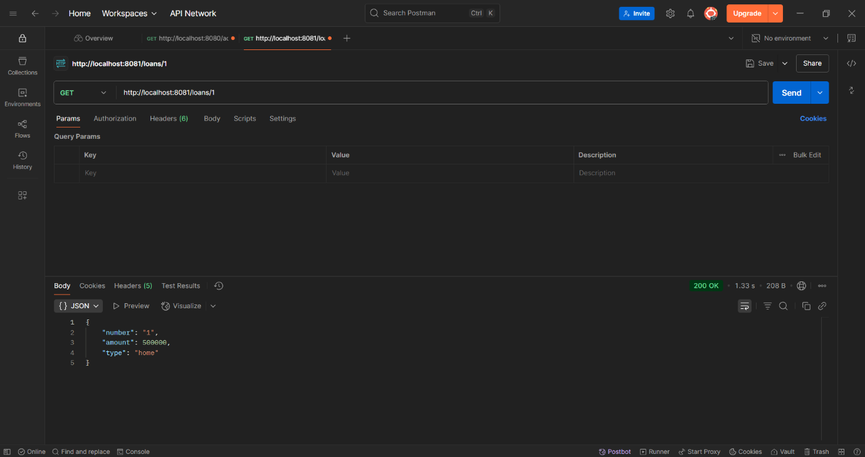

**Exercise 2: Create Eureka Discovery Server and register microservices**

**#account_project**

**Account.java**package com.cognizant.account;

public class Account {

private int accountNumber;

private String accountType;

private double balance;

public Account(int accountNumber, String accountType, double balance) {

this.accountNumber = accountNumber;

this.accountType = accountType;

this.balance = balance;

}

public int getAccountNumber() {

return accountNumber;

}

public String getAccountType() {

return accountType;

}

public double getBalance() {

return balance;

}

}

**AccountApplication.java**package com.cognizant.account;

import org.springframework.boot.SpringApplication;

import org.springframework.boot.autoconfigure.SpringBootApplication;

@SpringBootApplication

public class AccountApplication {

public static void main(String[] args) {

SpringApplication.run(AccountApplication.class, args);

}

}

**AccountController.java**package com.cognizant.account;

import org.springframework.web.bind.annotation.*;

*@RestController*

public class AccountController {

*@GetMapping*("/{number}")

public Account getAccountByNumber(*@PathVariable* int number) {

return new Account(number, "savings", 234343);

}

}

**application.properties**

spring.application.name=account-service

server.port=8080

eureka.client.service-url.defaultZone=http://localhost:8761/eureka

eureka.instance.hostname=localhost

eureka.instance.prefer-ip-address=true

**pom.xml**

<project xmlns="http://maven.apache.org/POM/4.0.0"

xmlns:xsi="http://www.w3.org/2001/XMLSchema-instance"

xsi:schemaLocation="http://maven.apache.org/POM/4.0.0

https://maven.apache.org/xsd/maven-4.0.0.xsd">

<modelVersion>4.0.0</modelVersion>

<parent>

<groupId>org.springframework.boot</groupId>

<artifactId>spring-boot-starter-parent</artifactId>

<version>3.5.3</version>

<relativePath/>

</parent>

<groupId>com.cognizant</groupId>

<artifactId>account</artifactId>

<version>0.0.1-SNAPSHOT</version>

<name>account</name>

<description>Account microservice</description>

<properties>

<java.version>17</java.version>

<spring-cloud.version>2025.0.0</spring-cloud.version>

</properties>

<dependencies>

<dependency>

<groupId>org.springframework.boot</groupId>

<artifactId>spring-boot-starter-web</artifactId>

</dependency>

<dependency>

<groupId>org.springframework.cloud</groupId>

<artifactId>spring-cloud-starter-netflix-eureka-client</artifactId>

</dependency>

<dependency>

<groupId>org.springframework.boot</groupId>

<artifactId>spring-boot-devtools</artifactId>

<scope>runtime</scope>

<optional>true</optional>

</dependency>

<dependency>

<groupId>org.springframework.boot</groupId>

<artifactId>spring-boot-starter-test</artifactId>

<scope>test</scope>

</dependency>

</dependencies>

<dependencyManagement>

<dependencies>

<dependency>

<groupId>org.springframework.cloud</groupId>

<artifactId>spring-cloud-dependencies</artifactId>

<version>${spring-cloud.version}</version>

<type>pom</type>

<scope>import</scope>

</dependency>

</dependencies>

</dependencyManagement>

<build>

<plugins>

<plugin>

<groupId>org.springframework.boot</groupId>

<artifactId>spring-boot-maven-plugin</artifactId>

</plugin>

</plugins>

</build>

</project>

**#loan_project**

**Loan.java**

package com.cognizant.loan;

public class Loan {

private int loanNumber;

private String loanType;

private double loanAmount;

public Loan(int loanNumber, String loanType, double loanAmount) {

this.loanNumber = loanNumber;

this.loanType = loanType;

this.loanAmount = loanAmount;

}

public int getLoanNumber() {

return loanNumber;

}

public String getLoanType() {

return loanType;

}

public double getLoanAmount() {

return loanAmount;

}

}

**LoanApplication.java**

package com.cognizant.loan;

import org.springframework.boot.SpringApplication;

import org.springframework.boot.autoconfigure.SpringBootApplication;

import org.springframework.cloud.client.discovery.EnableDiscoveryClient;

*@SpringBootApplication*

*@EnableDiscoveryClient*

public class LoanApplication {

public static void main(String[] args) {

SpringApplication.*run*(LoanApplication.class, args);

}

}

**LoanController.java**

package com.cognizant.loan;

import org.springframework.web.bind.annotation.*;

import java.util.HashMap;

import java.util.Map;

@RestController

@RequestMapping("/loans")

public class LoanController {

@GetMapping("/{number}")

public Map<String, Object> getLoanByNumber(@PathVariable String number) {

Map<String, Object> response = new HashMap<>();

response.put("number", number);

response.put("type", "home");

response.put("amount", 500000);

return response;

}

}

**application.properties**

spring.application.name=loan

server.port=8081

eureka.client.service-url.defaultZone=http://localhost:8761/eureka

**pom.xml**

<project xmlns="http://maven.apache.org/POM/4.0.0" xmlns:xsi="http://www.w3.org/2001/XMLSchema-instance" xsi:schemaLocation="http://maven.apache.org/POM/4.0.0 https://maven.apache.org/xsd/maven-4.0.0.xsd">

<modelVersion>4.0.0</modelVersion>

<parent>

<groupId>org.springframework.boot</groupId>

<artifactId>spring-boot-starter-parent</artifactId>

<version>3.5.3</version>

<relativePath/>

<!-- lookup parent from repository -->

</parent>

<groupId>com.example</groupId>

<artifactId>demo</artifactId>

<version>0.0.1-SNAPSHOT</version>

<name>demo</name>

<description>Demo project for Spring Boot</description>

<url/>

<licenses>

<license/>

</licenses>

<developers>

<developer/>

</developers>

<scm>

<connection/>

<developerConnection/>

<tag/>

<url/>

</scm>

<properties>

<java.version>17</java.version>

<spring-cloud.version>2025.0.0</spring-cloud.version>

</properties>

<dependencies>

<dependency>

<groupId>org.springframework.boot</groupId>

<artifactId>spring-boot-starter-web</artifactId>

</dependency>

<dependency>

<groupId>org.springframework.cloud</groupId>

<artifactId>spring-cloud-starter-netflix-eureka-client</artifactId>

</dependency>

<dependency>

<groupId>org.springframework.boot</groupId>

<artifactId>spring-boot-devtools</artifactId>

<scope>runtime</scope>

<optional>true</optional>

</dependency>

<dependency>

<groupId>org.springframework.boot</groupId>

<artifactId>spring-boot-starter-test</artifactId>

<scope>test</scope>

</dependency>

</dependencies>

<dependencyManagement>

<dependencies>

<dependency>

<groupId>org.springframework.cloud</groupId>

<artifactId>spring-cloud-dependencies</artifactId>

<version>${spring-cloud.version}</version>

<type>pom</type>

<scope>import</scope>

</dependency>

</dependencies>

</dependencyManagement>

<build>

<plugins>

<plugin>

<groupId>org.springframework.boot</groupId>

<artifactId>spring-boot-maven-plugin</artifactId>

</plugin>

</plugins>

</build>

</project>

**#demo_project**

**DemoApplication**

package com.example.demo;

import org.springframework.boot.SpringApplication;

import org.springframework.boot.autoconfigure.SpringBootApplication;

import org.springframework.cloud.client.discovery.EnableDiscoveryClient;

*@SpringBootApplication*

*@EnableDiscoveryClient*

public class DemoApplication {

public static void main(String[] args) {

SpringApplication.*run*(DemoApplication.class, args);

}

}

**application.properties**

spring.application.name=demo

**pom.xml**

<?xml version="1.0" encoding="UTF-8"?>

<project xmlns="http://maven.apache.org/POM/4.0.0" xmlns:xsi="http://www.w3.org/2001/XMLSchema-instance" xsi:schemaLocation="http://maven.apache.org/POM/4.0.0 https://maven.apache.org/xsd/maven-4.0.0.xsd">

<modelVersion>4.0.0</modelVersion>

<parent>

<groupId>org.springframework.boot</groupId>

<artifactId>spring-boot-starter-parent</artifactId>

<version>3.5.3</version>

<relativePath/> <!-- lookup parent from repository -->

</parent>

<groupId>com.example</groupId>

<artifactId>demo</artifactId>

<version>0.0.1-SNAPSHOT</version>

<name>demo</name>

<description>Demo project for Spring Boot</description>

<properties>

<java.version>17</java.version>

<spring-cloud.version>2025.0.0</spring-cloud.version>

</properties>

<dependencies>

<dependency>

<groupId>org.springframework.boot</groupId>

<artifactId>spring-boot-starter-data-jpa</artifactId>

</dependency>

<dependency>

<groupId>org.springframework.boot</groupId>

<artifactId>spring-boot-starter-web</artifactId>

</dependency>

<dependency>

<groupId>com.h2database</groupId>

<artifactId>h2</artifactId>

<scope>runtime</scope>

</dependency>

<dependency>

<groupId>org.projectlombok</groupId>

<artifactId>lombok</artifactId>

<optional>true</optional>

</dependency>

<dependency>

<groupId>org.springframework.cloud</groupId>

<artifactId>spring-cloud-starter-netflix-eureka-client</artifactId>

</dependency>

<dependency>

<groupId>org.springframework.boot</groupId>

<artifactId>spring-boot-starter-test</artifactId>

<scope>test</scope>

</dependency>

</dependencies>

<dependencyManagement>

<dependencies>

<dependency>

<groupId>org.springframework.cloud</groupId>

<artifactId>spring-cloud-dependencies</artifactId>

<version>${spring-cloud.version}</version>

<type>pom</type>

<scope>import</scope>

</dependency>

</dependencies>

</dependencyManagement>

<build>

<plugins>

<plugin>

<groupId>org.apache.maven.plugins</groupId>

<artifactId>maven-compiler-plugin</artifactId>

<configuration>

<annotationProcessorPaths>

<path>

<groupId>org.projectlombok</groupId>

<artifactId>lombok</artifactId>

</path>

</annotationProcessorPaths>

</configuration>

</plugin>

<plugin>

<groupId>org.springframework.boot</groupId>

<artifactId>spring-boot-maven-plugin</artifactId>

<configuration>

<excludes>

<exclude>

<groupId>org.projectlombok</groupId>

<artifactId>lombok</artifactId>

</exclude>

</excludes>

</configuration>

</plugin>

</plugins>

</build>

</project>

**#eureka_discovery_server**

package com.cognizant.eureka_discovery_server;

import org.springframework.boot.SpringApplication;

import org.springframework.boot.autoconfigure.SpringBootApplication;

import org.springframework.cloud.netflix.eureka.server.EnableEurekaServer;

*@SpringBootApplication*

*@EnableEurekaServer*

public class EurekaDiscoveryServerApplication {

public static void main(String[] args) {

SpringApplication.*run*(EurekaDiscoveryServerApplication.class, args);

}

}

**application.properties**

spring.application.name=eureka-discovery-server

server.port=8761

# Don't register this Eureka server to itself

eureka.client.register-with-eureka=false

eureka.client.fetch-registry=false

# Optional: Turn off unnecessary logging

logging.level.com.netflix.eureka=OFF

logging.level.com.netflix.discovery=OFF

**pom.xml**

<?xml version="1.0" encoding="UTF-8"?>

<project xmlns="http://maven.apache.org/POM/4.0.0" xmlns:xsi="http://www.w3.org/2001/XMLSchema-instance"

xsi:schemaLocation="http://maven.apache.org/POM/4.0.0 https://maven.apache.org/xsd/maven-4.0.0.xsd">

<modelVersion>4.0.0</modelVersion>

<parent>

<groupId>org.springframework.boot</groupId>

<artifactId>spring-boot-starter-parent</artifactId>

<version>3.5.3</version>

<relativePath/> <!-- lookup parent from repository -->

</parent>

<groupId>com.cognizant</groupId>

<artifactId>eureka-discovery-server</artifactId>

<version>0.0.1-SNAPSHOT</version>

<name>eureka-discovery-server</name>

<description>Demo project for Spring Boot</description>

<url/>

<licenses>

<license/>

</licenses>

<developers>

<developer/>

</developers>

<scm>

<connection/>

<developerConnection/>

<tag/>

<url/>

</scm>

<properties>

<java.version>17</java.version>

<spring-cloud.version>2025.0.0</spring-cloud.version>

</properties>

<dependencies>

<dependency>

<groupId>org.springframework.cloud</groupId>

<artifactId>spring-cloud-starter-netflix-eureka-server</artifactId>

</dependency>

<dependency>

<groupId>org.springframework.boot</groupId>

<artifactId>spring-boot-devtools</artifactId>

<scope>runtime</scope>

<optional>true</optional>

</dependency>

<dependency>

<groupId>org.springframework.boot</groupId>

<artifactId>spring-boot-starter-test</artifactId>

<scope>test</scope>

</dependency>

</dependencies>

<dependencyManagement>

<dependencies>

<dependency>

<groupId>org.springframework.cloud</groupId>

<artifactId>spring-cloud-dependencies</artifactId>

<version>${spring-cloud.version}</version>

<type>pom</type>

<scope>import</scope>

</dependency>

</dependencies>

</dependencyManagement>

<build>

<plugins>

<plugin>

<groupId>org.springframework.boot</groupId>

<artifactId>spring-boot-maven-plugin</artifactId>

</plugin>

</plugins>

</build>

</project>

**#api_gateway**

**ApiGatewayApplication**

package com.cognizant.api_gateway;

import org.springframework.boot.SpringApplication;

import org.springframework.boot.autoconfigure.SpringBootApplication;

import org.springframework.cloud.client.discovery.EnableDiscoveryClient;

*@SpringBootApplication*

*@EnableDiscoveryClient*

public class ApiGatewayApplication {

public static void main(String[] args) {

SpringApplication.*run*(ApiGatewayApplication.class, args);

}

}

**LogFilter.java**

package com.cognizant.api_gateway;

import org.springframework.cloud.gateway.filter.GatewayFilterChain;

import org.springframework.cloud.gateway.filter.GlobalFilter;

import org.springframework.core.Ordered;

import org.springframework.stereotype.Component;

import org.springframework.web.server.ServerWebExchange;

import reactor.core.publisher.Mono;

@Component

public class LogFilter implements GlobalFilter, Ordered {

@Override

public Mono<Void> filter(ServerWebExchange exchange, GatewayFilterChain chain) {

System.out.println("Incoming request: " + exchange.getRequest().getURI());

return chain.filter(exchange);

}

@Override

public int getOrder() {

return -1; // Highest precedence

}

}

**application.properties**

spring.application.name=api-gateway

server.port=9090

eureka.client.service-url.defaultZone=http://localhost:8761/eureka/

eureka.instance.prefer-ip-address=true

spring.cloud.gateway.routes[0].id=account-service

spring.cloud.gateway.routes[0].uri=lb://account-service

spring.cloud.gateway.routes[0].predicates[0]=Path=/accounts/**

spring.cloud.gateway.routes[0].filters[0]=StripPrefix=1

spring.cloud.gateway.routes[1].id=loan-service

spring.cloud.gateway.routes[1].uri=lb://loan

spring.cloud.gateway.routes[1].predicates[0]=Path=/loans/**

spring.cloud.gateway.routes[1].filters[0]=StripPrefix=1

logging.level.org.springframework.cloud.gateway=DEBUG

logging.level.reactor.netty.http.client=DEBUG

**pom.xml**

<?xml version="1.0" encoding="UTF-8"?>

<project xmlns="http://maven.apache.org/POM/4.0.0" xmlns:xsi="http://www.w3.org/2001/XMLSchema-instance"

xsi:schemaLocation="http://maven.apache.org/POM/4.0.0 https://maven.apache.org/xsd/maven-4.0.0.xsd">

<modelVersion>4.0.0</modelVersion>

<parent>

<groupId>org.springframework.boot</groupId>

<artifactId>spring-boot-starter-parent</artifactId>

<version>3.5.3</version>

<relativePath/> <!-- lookup parent from repository -->

</parent>

<groupId>com.cognizant</groupId>

<artifactId>api-gateway</artifactId>

<version>0.0.1-SNAPSHOT</version>

<name>api-gateway</name>

<description>API Gateway for routing microservices</description>

<url/>

<licenses>

<license/>

</licenses>

<developers>

<developer/>

</developers>

<scm>

<connection/>

<developerConnection/>

<tag/>

<url/>

</scm>

<properties>

<java.version>17</java.version>

<spring-cloud.version>2025.0.0</spring-cloud.version>

</properties>

<dependencies>

<dependency>

<groupId>org.springframework.boot</groupId>

<artifactId>spring-boot-starter-actuator</artifactId>

</dependency>

<dependency> <groupId>org.springframework.cloud</groupId> <artifactId>spring-cloud-starter-gateway-server-webflux</artifactId> </dependency>

<dependency>

<groupId>org.springframework.cloud</groupId>

<artifactId>spring-cloud-starter-netflix-eureka-client</artifactId>

</dependency>

<dependency>

<groupId>org.springframework.boot</groupId>

<artifactId>spring-boot-devtools</artifactId>

<scope>runtime</scope>

<optional>true</optional>

</dependency>

<dependency>

<groupId>org.springframework.boot</groupId>

<artifactId>spring-boot-starter-test</artifactId>

<scope>test</scope>

</dependency>

</dependencies>

<dependencyManagement>

<dependencies>

<dependency>

<groupId>org.springframework.cloud</groupId>

<artifactId>spring-cloud-dependencies</artifactId>

<version>${spring-cloud.version}</version>

<type>pom</type>

<scope>import</scope>

</dependency>

</dependencies>

</dependencyManagement>

<build>

<plugins>

<plugin>

<groupId>org.springframework.boot</groupId>

<artifactId>spring-boot-maven-plugin</artifactId>

</plugin>

</plugins>

</build>

</project>

**Output:**

